ABIGAIL BENS
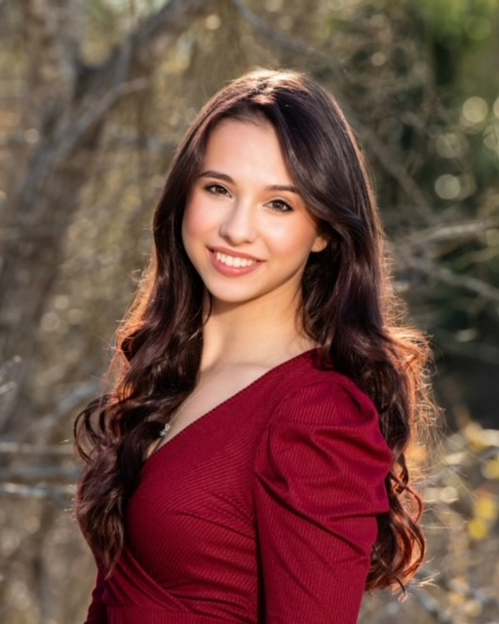
512-944-0917
abigail.bensman@gmail.com
Height: 5’2”
Vocal Type: Soprano/Belt

THEATRE
NEWSIES Katherine Zilker Theatre Productions / Joey Banks
BRING IT ON Eva Summer Stock Austin
Ginger Morris, J QUINTON JOHNSON, Hunter Regian
SWEENEY TODD Johanna Southwestern University / Joey Banks
SHE KILLS MONSTERS Evil Tina Southwestern University / Marcus McQuirter
STEEL MAGNOLIAS Annelle Georgetown Palace / Emily Taylor
BRIGHT STAR Alice Murphy Round Rock Theatre / Johanna Whitmore
TARZAN THE MUSICAL Jane Porter Round Rock Theatre / Johanna Whitmore
OUR TOWN Emily Webb Round Rock Theatre / Johanna Whitmore
ANDROCLES AND THE LION Androcles Round Rock Theatre / Charles Hobby
A MIDSUMMER NIGHT’S DREAM Hermia Round Rock Theatre / Charles Hobby
EURYDICE Eurydice Round Rock Theatre / Clayton Berger

AWARDS
B. IDEN PAYNE winner 2021 “Outstanding Young Performer” Bring it On (Eva) Summer Stock Austin
Heller Awards for Young Artists (HAYA) nominee 2021 “Senior Solo Musical Theatre”
Music Captain, Bring It On, after J QUINTON JOHNSON returned to Broadway’s Hamilton
International and Texas State Thespian Festivals, Superior Ratings Group Musical
UIL One Act – All Star Cast Award
Best Actress, Best Supporting Actress – Round Rock Theatre

TRAINING / SKILLS
Southwestern University – Theatre (Musical Theatre / Performance) ‘25
Voice – Katherine Altobello, Jessica Waterhouse
Tumbling – Capital Gymnastics | Cheer
Jazz, Tap, Ballet, Hip Hop – Georgetown Palace, The Dance Works
Scene Study – Zach Scott
Workshops: Movement, Acting, Dance, Vocals – International and Texas State Thespian Festivals
Dialects – IPA, Cockney, Southern, New York
Fully Vaccinated

